VOIGT EFFECT

Substrate-Dependent Structural Evolution Under Repeated Stress in Computational Systems

Multi-Environment Empirical Evidence with Temporal Stability Metrics

Rafael Felippe Voigt
Independent Researcher — VCore Project
ORCID: https://orcid.org/0009-0001-1091-8398
Framework: VCore — Temporal Governance Framework
Theoretical Foundation: Voigtian Field Theory
Canonical DOI: https://doi.org/10.5281/zenodo.18249999

Abstract

This work presents high-resolution empirical evidence of the Voigt Effect, a structural phenomenon in computational systems whereby repeated stress cycles induce persistent baseline transformation, even after apparent operational recovery.
Controlled experiments were conducted across three execution substrates:
- Virtualized Linux VPS (Munich)
- Bare-metal Windows system (Notebook 1 — i7, 8GB RAM, SSD)
- Bare-metal Windows system (Notebook 2 — i5, 4GB RAM, SSD)
Despite similar stress conditions, results show divergent structural trajectories:
- The virtualized system exhibits progressive baseline degradation, with Time-To-Risk (TTC) collapsing from ~160s to ~33s and stabilizing at lower levels (~115–125s).
- Both physical systems demonstrate baseline restoration, with TTC returning to equilibrium (~84–100s) and, in the lower-capacity system, even exceeding prior baseline (~92s).
These findings demonstrate that:
- structural evolution is substrate-dependent
- recovery is not equivalent to restoration
- stability is a temporal and historical property
This work establishes the Voigt Effect as the first empirically observed phenomenon within the Voigtian Field, bridging theoretical formulation and experimental validation.

Keywords
Voigt Effect, Time-To-Risk, Structural Stability, Computational Systems, Virtualization, Bare Metal, Temporal Dynamics, Entropic Degradation, Runtime Behavior

1. Introduction

Modern computational observability assumes that systems return to their original baseline after stress.
This assumption is operationally convenient—but empirically incorrect.
Through controlled experimentation, a structural asymmetry emerges:
Systems may recover functionally while remaining structurally altered.
This work formalizes and validates the Voigt Effect, demonstrating that computational systems evolve structurally under repeated stress, and that such evolution is strongly conditioned by the execution substrate.

2. Theoretical Framework

2.1 Voigtian Field
The Voigtian Field models computational stability as a function of temporal coherence, rather than instantaneous state.

2.2 Temporal Structural Metrics
The VCore framework introduces observability through:
- Time-To-Risk (TTC): forward-looking stability horizon
- Recovery Strength (Inertia Engine): reactive capacity
- System Risk: current instability state
These metrics collectively describe structural behavior across time.

2.3 Living Baseline
System baselines are not static—they are:
- dynamic
- history-dependent
- structurally mutable
Repeated stress can permanently alter the baseline.

3. Definition of the Voigt Effect
The Voigt Effect is defined as a persistent transformation of a system’s structural baseline induced by repeated stress cycles, observable through temporal metrics such as TTC, even after apparent recovery.
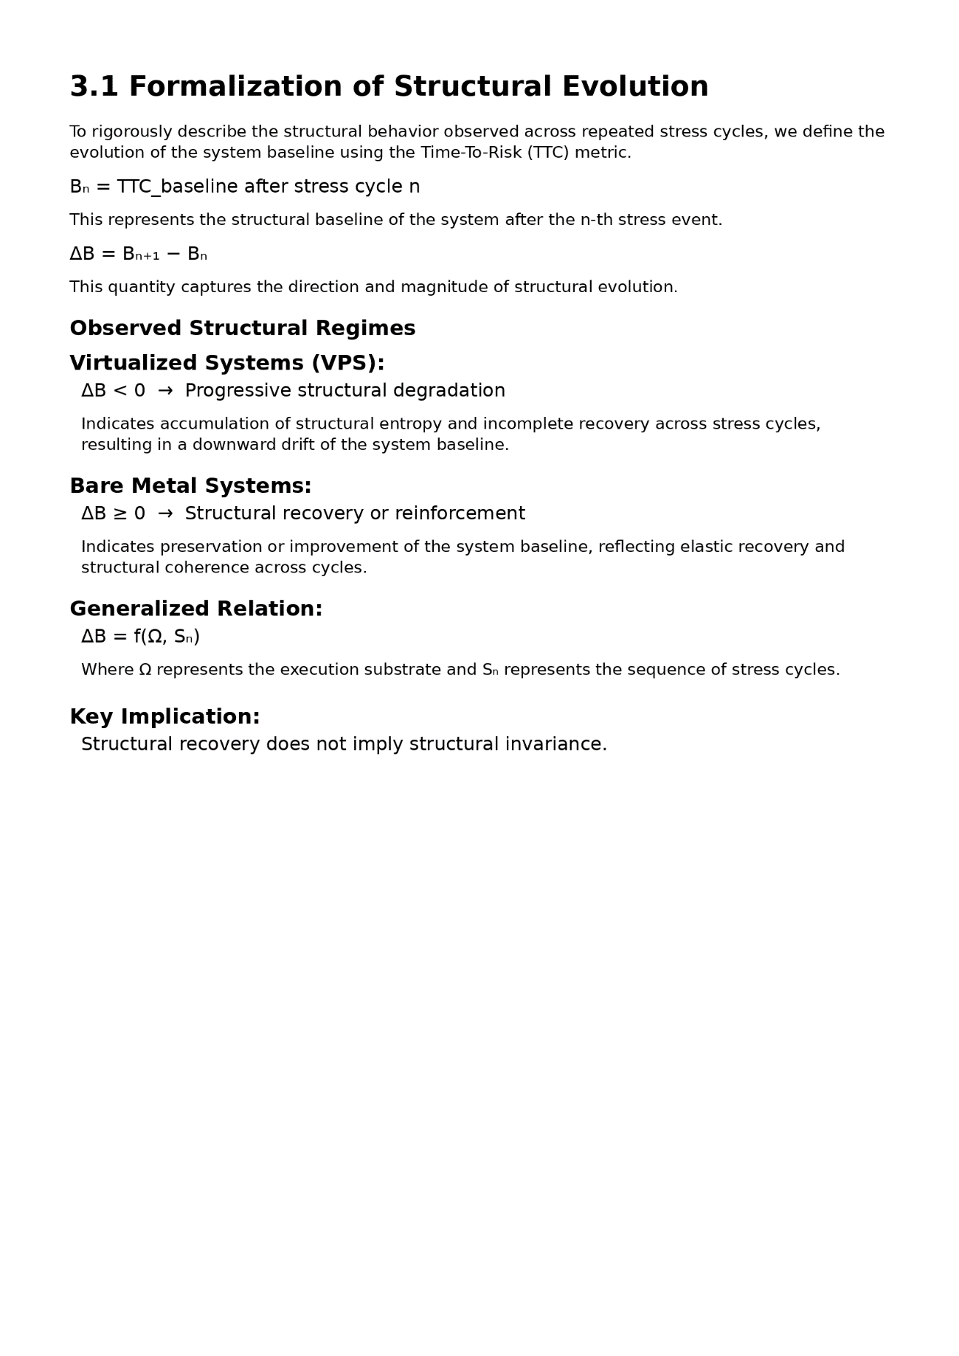

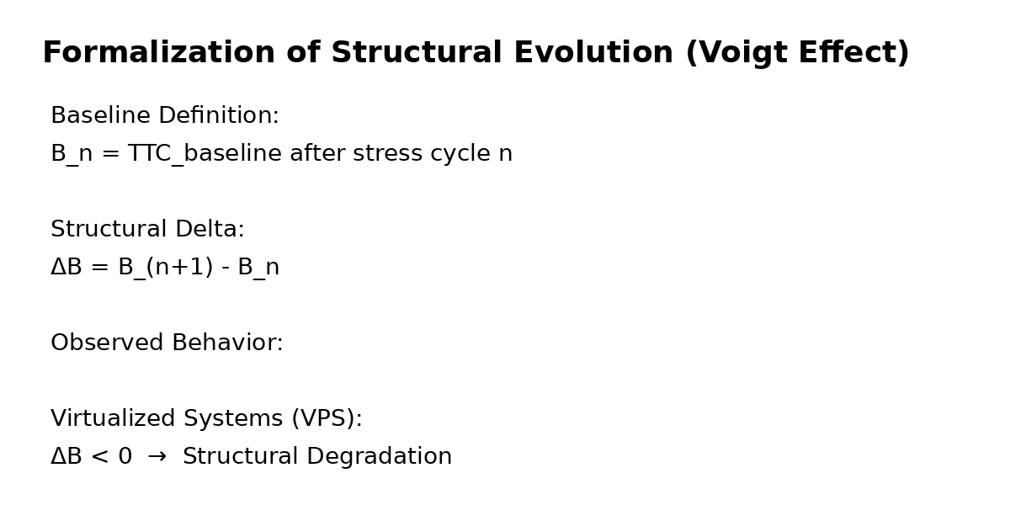

4. Experimental Design

4.1 Environments

Environment A — Virtualized System
- Location: Munich (VPS)
- OS: Linux
- Resources: 4 vCPU, 8GB RAM, 240GB disk
- Characteristics: shared infrastructure, scheduler-mediated resources

Environment B — Bare Metal (Notebook 1)
- OS: Windows
- CPU: Intel i7
- RAM: 8GB
- Storage: 128GB SSD
- Characteristics: direct hardware execution

Environment C — Bare Metal (Notebook 2)
- OS: Windows
- CPU: Intel i5
- RAM: 4GB
- Storage: 240GB SSD
- Characteristics: lower capacity, same execution model

4.2 Stress Protocol
Linux: stress-ng --cpu 8 --vm 2 --vm-bytes 6G --timeout 120s
Windows: multi-process stress induced via concurrent I/O, memory pressure, and CPU-bound operations.

4.3 Methodology
- Establish baseline TTC
- Apply controlled stress
- Observe structural response
- Measure post-stress TTC
- Repeat cycles

4.4 Observability Note
Virtualization introduces:
- CPU throttling
- scheduling abstraction
- resource contention
These are treated as intrinsic structural properties, not noise.

5. Results

5.1 Virtualized Environment (Munich VPS)
Observed behavior:
- Initial TTC: ~160 seconds
- Minimum TTC: ~33 seconds
- Post-stress stabilization: ~115–125 seconds
Pattern:
- monotonic degradation
- incomplete recovery
- downward baseline drift
Interpretation:
→ Cumulative structural entropy

5.2 Bare Metal — Notebook 1 (i7, 8GB)
Observed behavior:
- TTC fluctuates under stress
- TTC consistently returns to baseline (~84–100s)
Pattern:
- stable recovery
- preserved structural integrity
Interpretation:
→ Elastic structural behavior

5.3 Bare Metal — Notebook 2 (i5, 4GB)
Observed behavior:
- TTC reaches ~92 seconds after stress
- baseline restored or slightly exceeded
Pattern:
- recovery independent of hardware strength
- adaptive reinforcement
Interpretation:
→ Structural resilience exceeds capacity constraints

6. Comparative Analysis
Dimension | VPS (Linux) | Notebook 1 | Notebook 2
Baseline Behavior | Degrading | Stable | Improving
Recovery | Partial | Full | Full
TTC Trend | Downward | Neutral | Upward
Structural Memory | Entropic | Neutral | Adaptive

7. Figure 1 — TTC Structural Evolution Across Substrates
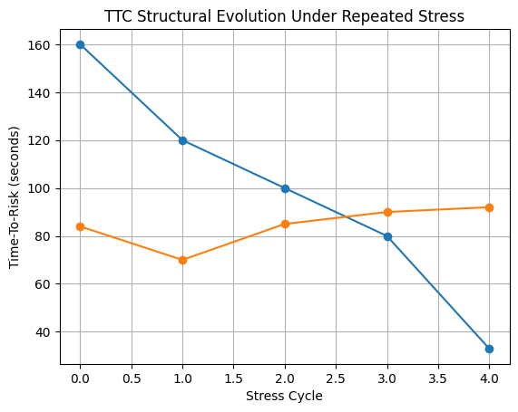
Description:
This figure illustrates TTC evolution across repeated stress cycles in all three environments.
- VPS shows progressive collapse and incomplete recovery
- Notebook 1 shows baseline restoration
- Notebook 2 shows adaptive reinforcement

8. Empirical Evidence — Visual Documentation

Pre-stress (Healthy baseline) 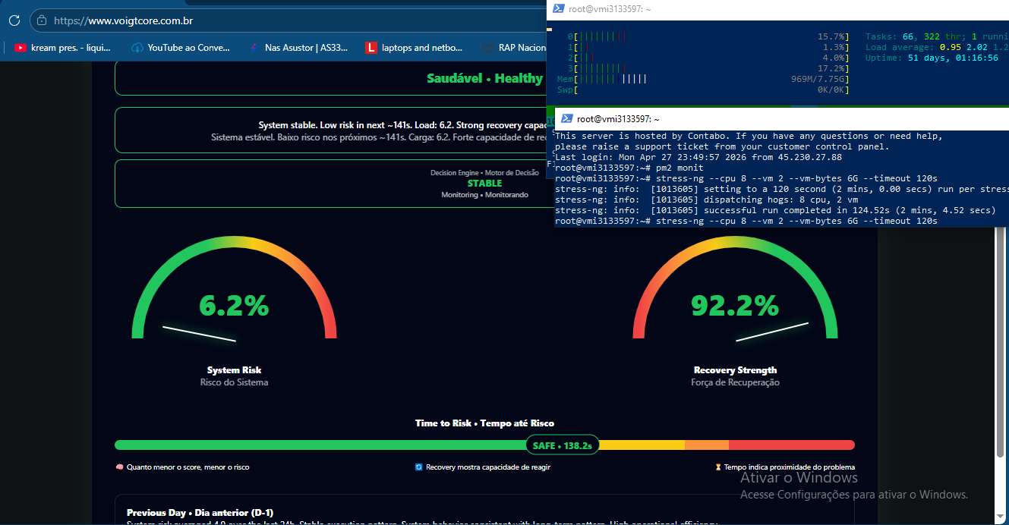

Critical state (~34s TTC) 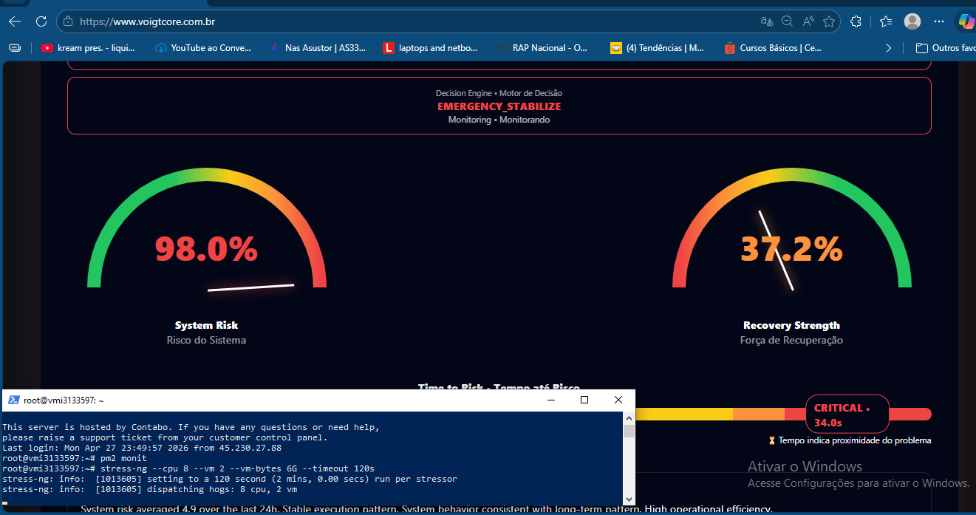

Post-stress degraded baseline 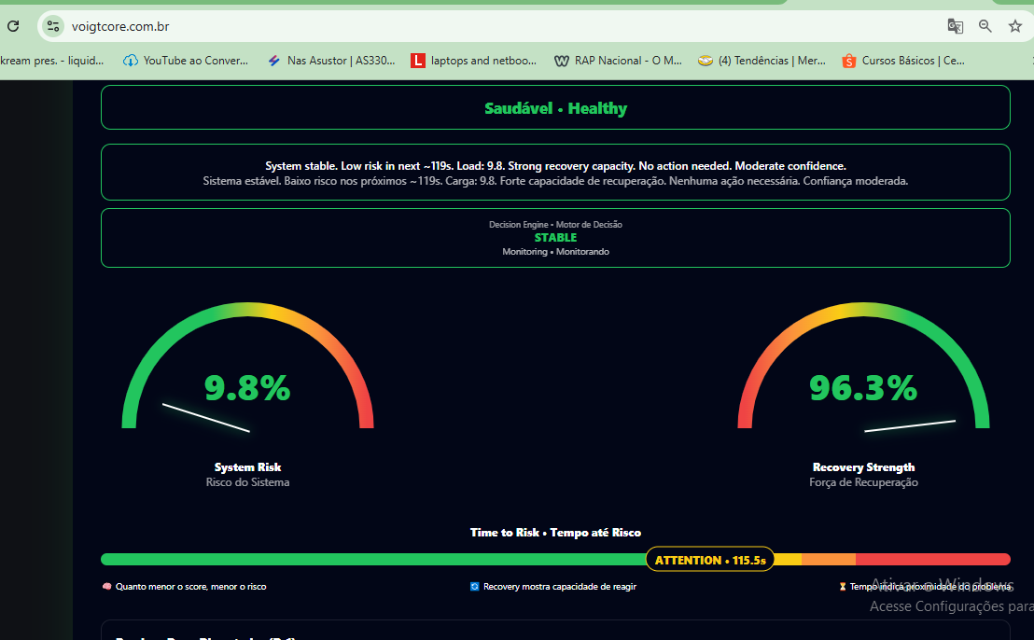

Notebook 1

Pre-stress – Elevated light

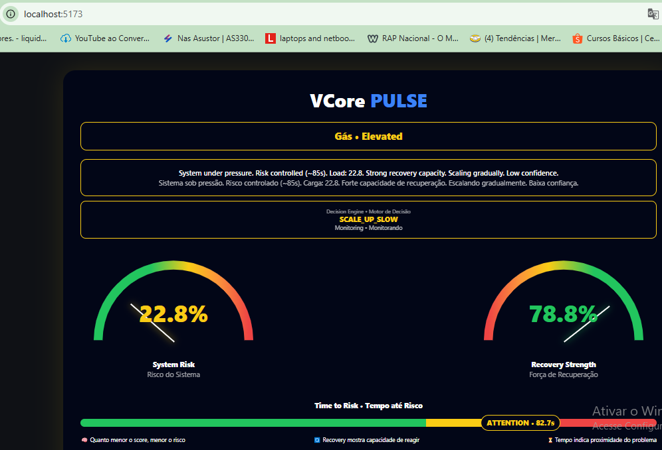

Critical state (~74s TTC)

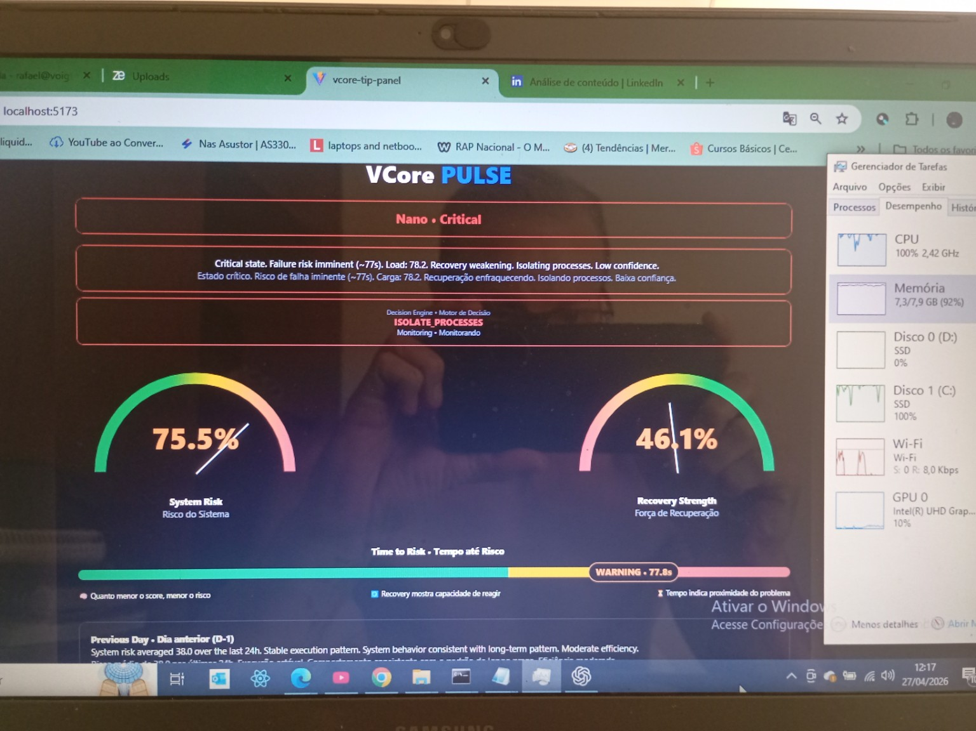

Voigt Effect

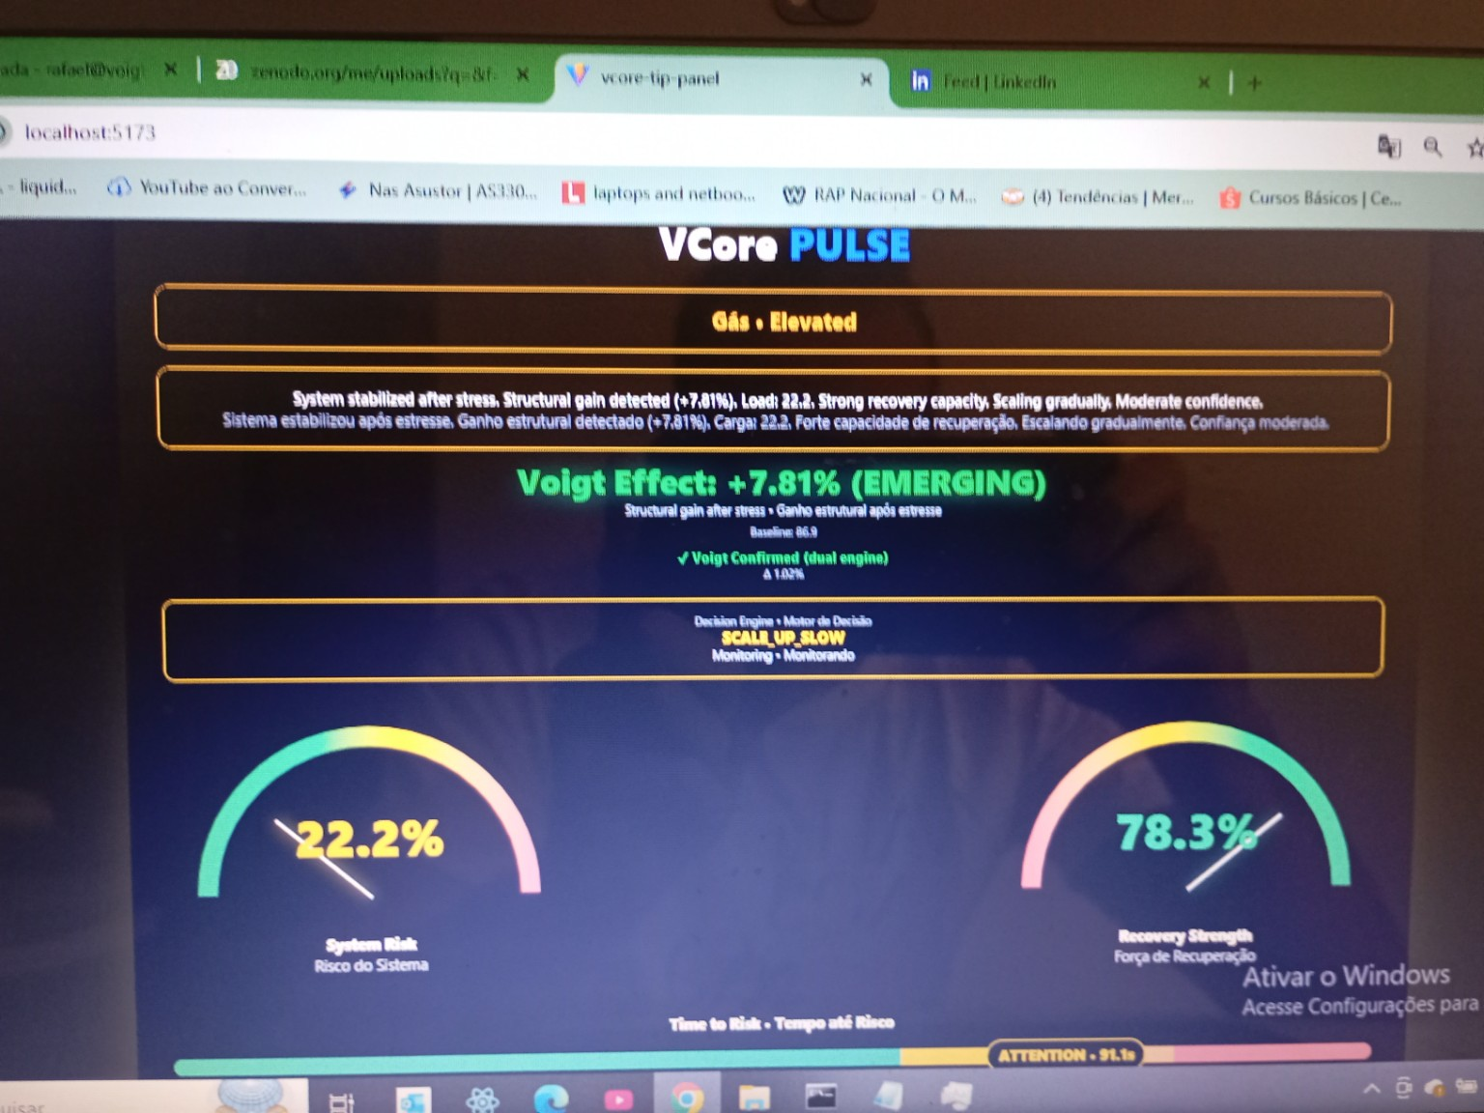

Voigt Effect

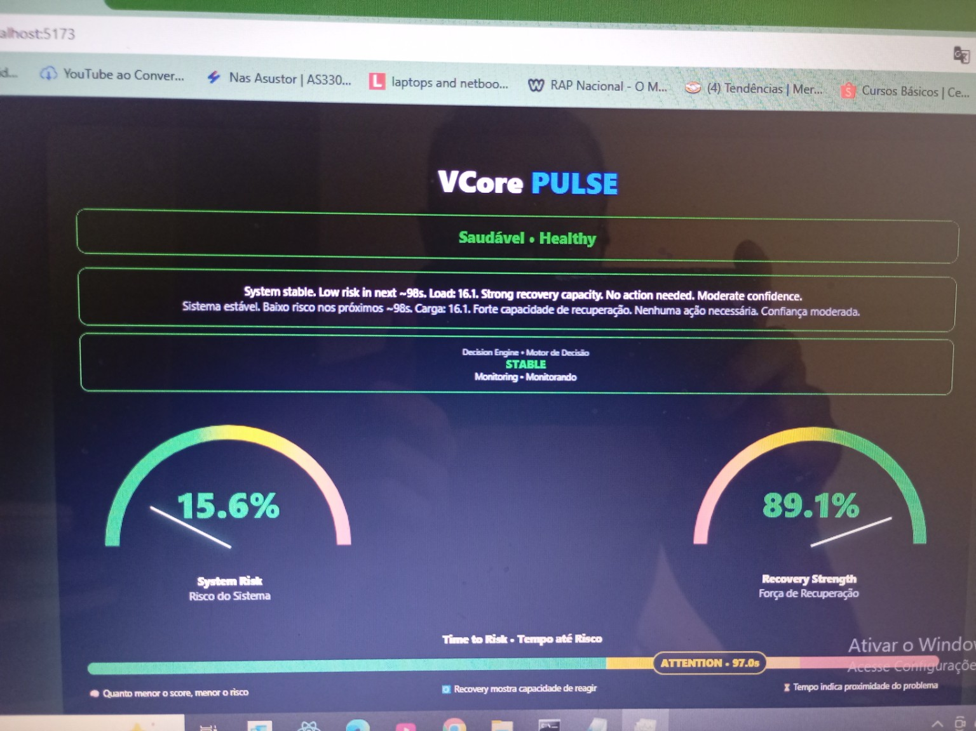

Notebook 2

Pre-stress – Elevated light
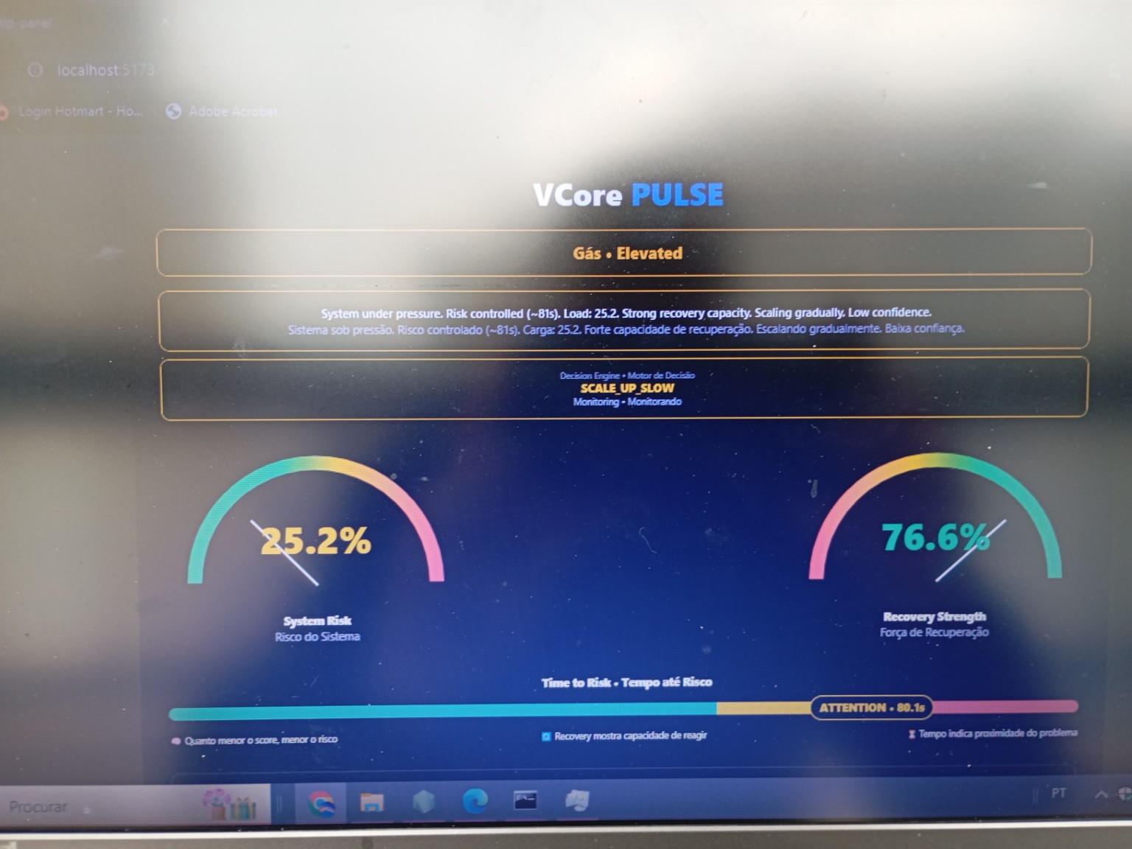

Stressed – TTC 64~
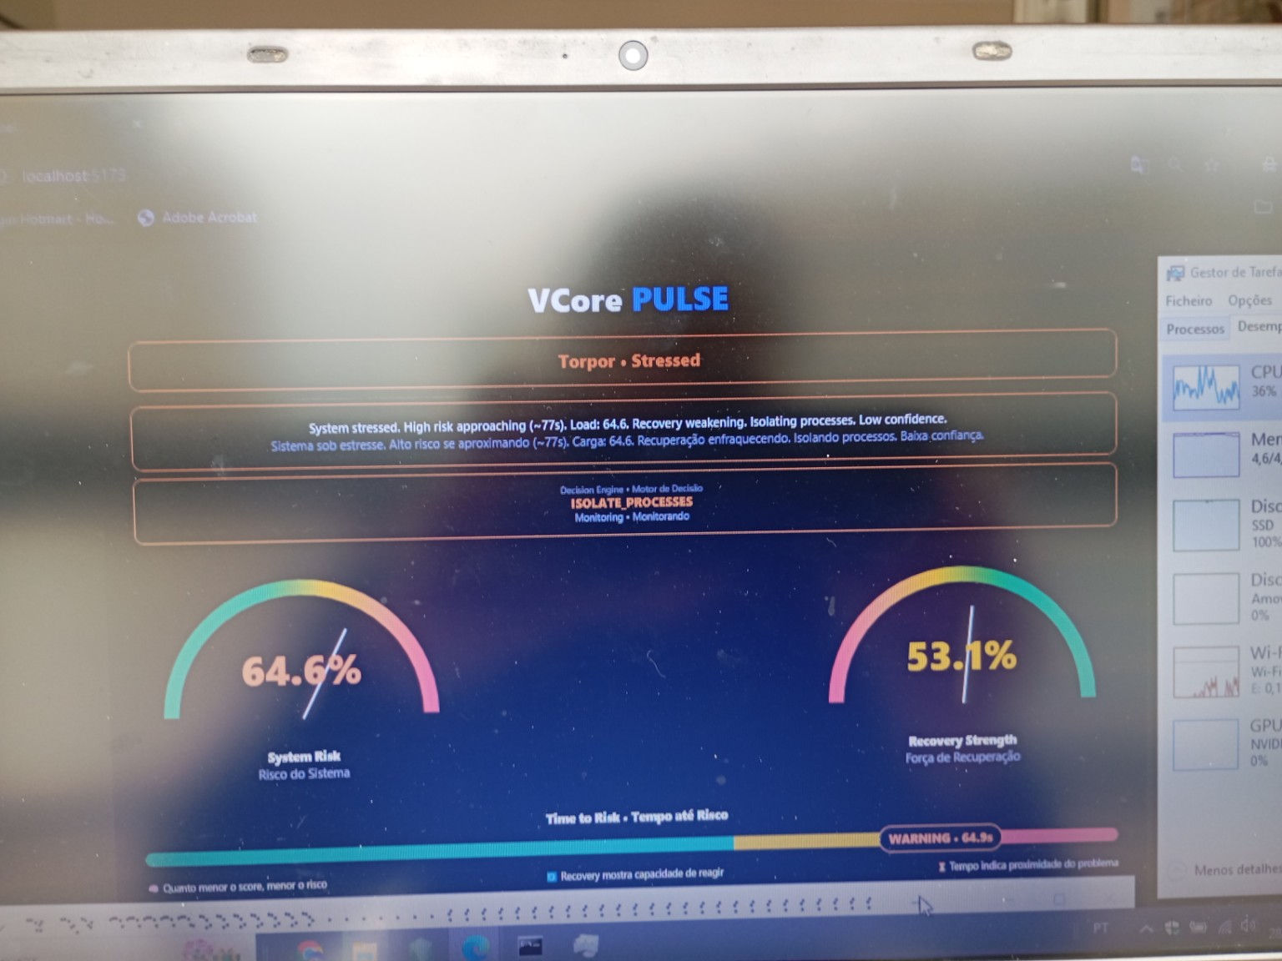

Voigt Effect
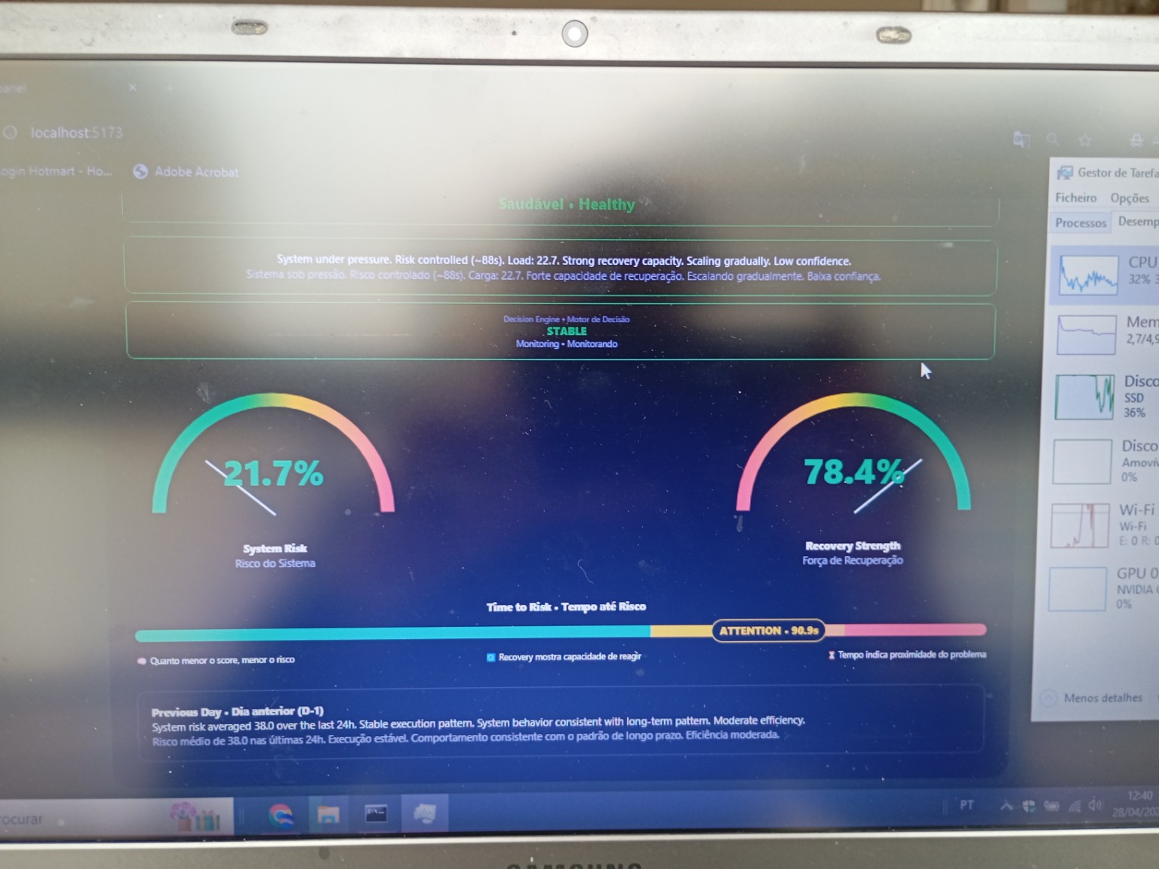

9. Core Findings

9.1 Structural Memory Exists
Systems retain historical stress effects beyond visible recovery.

9.2 Substrate Defines Outcome
Execution model determines structural trajectory more than hardware capacity.

9.3 Recovery is Not Restoration
High recovery strength does not imply baseline integrity.

9.4 Virtualization Introduces Entropic Bias
Shared environments accumulate structural degradation across cycles.

9.5 Limitations
- Experiments conducted on limited hardware set
- Virtualization provider-specific behavior
- Absence of kernel-level instrumentation
- TTC derived from framework-specific metrics

10. Discussion
The divergence between environments reveals a fundamental limitation in classical system modeling:
- Traditional metrics measure state
- Voigtian metrics capture structural evolution
This distinction exposes hidden instability layers, particularly in virtualized systems.

11. Conclusion
This work establishes the Voigt Effect as a validated structural phenomenon in computational systems.
Three fundamental principles emerge:

1. Stability is Temporal
System stability is shaped by accumulated stress history, not instantaneous state.

2. Structural Behavior is Substrate-Dependent
The execution environment determines whether systems degrade, stabilize, or improve.

3. Structural Memory Persists
Systems do not inherently return to their original baseline.

Critically:
Operational recovery does not imply structural equivalence.

The experiments further demonstrate that:
- Bare-metal systems preserve or reinforce structural coherence
- Virtualized systems accumulate irreversible degradation

This confirms that:
Stability is a temporal-structural property governed by the computational substrate.

The Voigt Effect represents a transition from:
- static system modeling
→ to
- dynamic structural observability

References

SSRN
https://papers.ssrn.com/sol3/papers.cfm?abstract_id=6168911
SSRN
https://papers.ssrn.com/sol3/papers.cfm?abstract_id=6397018
ResearchGate
https://www.researchgate.net/publication/401969333
Zenodo (Canonical Framework)
https://doi.org/10.5281/zenodo.18249999
ORCID
https://orcid.org/0009-0001-1091-8398

